**SQL Assignment 1**

create database Northwind

create table Product(

ProductID int NOT NULL Primary key,

ProductName varchar(40) NOT NULL,

SupplierID int NOT NULL,

CategoryID int NOT NULL,

QuantityPerUnit varchar(20) NOT NULL,

UnitPrice decimal(10,4) NOT NULL,

UnitsInStock smallint NOT NULL,

UnitsOnOrder smallint NOT NULL,

ReorderLevel smallint NOT NULL,

Discontinued bit NOT NULL

)

select * from Product

insert into Product VALUES('1', 'Chai','1','1','10 cups', '10' , '27' , '0' , '10' , '0')

insert into Product VALUES('2', 'Coffee','1','1','20 cups', '30' , '45' , '10' ,'15' ,'0')

insert into Product VALUES('3', 'apple juice','2','1','5 glasses', '70' , '20' , '3' ,'5' ,'1')

insert into Product VALUES('4', 'coco','2','1','10 glasses','110' , '30' ,'7' ,'13' ,'0')

insert into Product VALUES('5', 'badam Shake','3','2','20 glasses','150' ,'25' ,'0' ,'5' ,'0')

insert into Product VALUES('6', 'fruits','4','3','5 bowls','80' , '20' ,'3' ,'7' ,'1')

insert into Product VALUES('7', 'soup','4','3','5 bowls','60' , '40' ,'10' ,'5' ,'1')

insert into Product VALUES('8', 'sweet','2','1','50 pieces','30' , '300' ,'100' ,'50' ,'0')

insert into Product VALUES('9', 'candy','3','4','40 pieces','35' , '100' ,'10' ,'30' ,'0')

insert into Product values('10','black water','1','1','20 glasses','20','50','0','10','0')

**1.** **Write a query to get a Product list (id, name, unit price) where current products cost less than $20.**

select ProductID, ProductName,UnitPrice from Product where ((UnitPrice < 20) AND Discontinued = 0 )

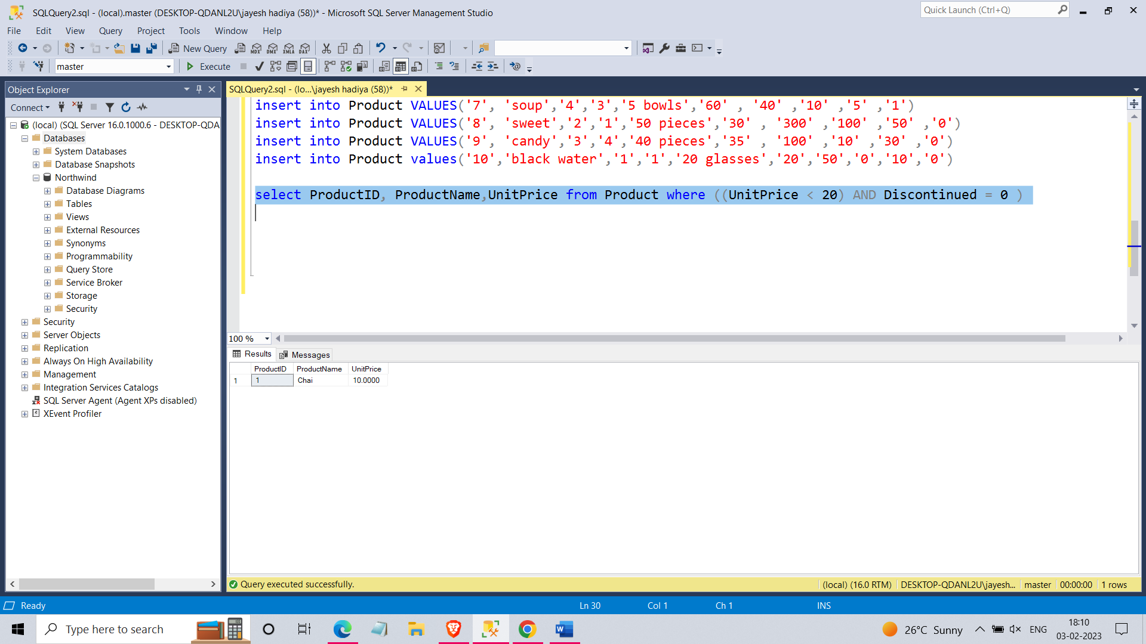

**2. Write a query to get Product list (id, name, unit price) where products cost between $15 and $25**

select ProductID, ProductName,UnitPrice from Product where UnitPrice between 15 and 25

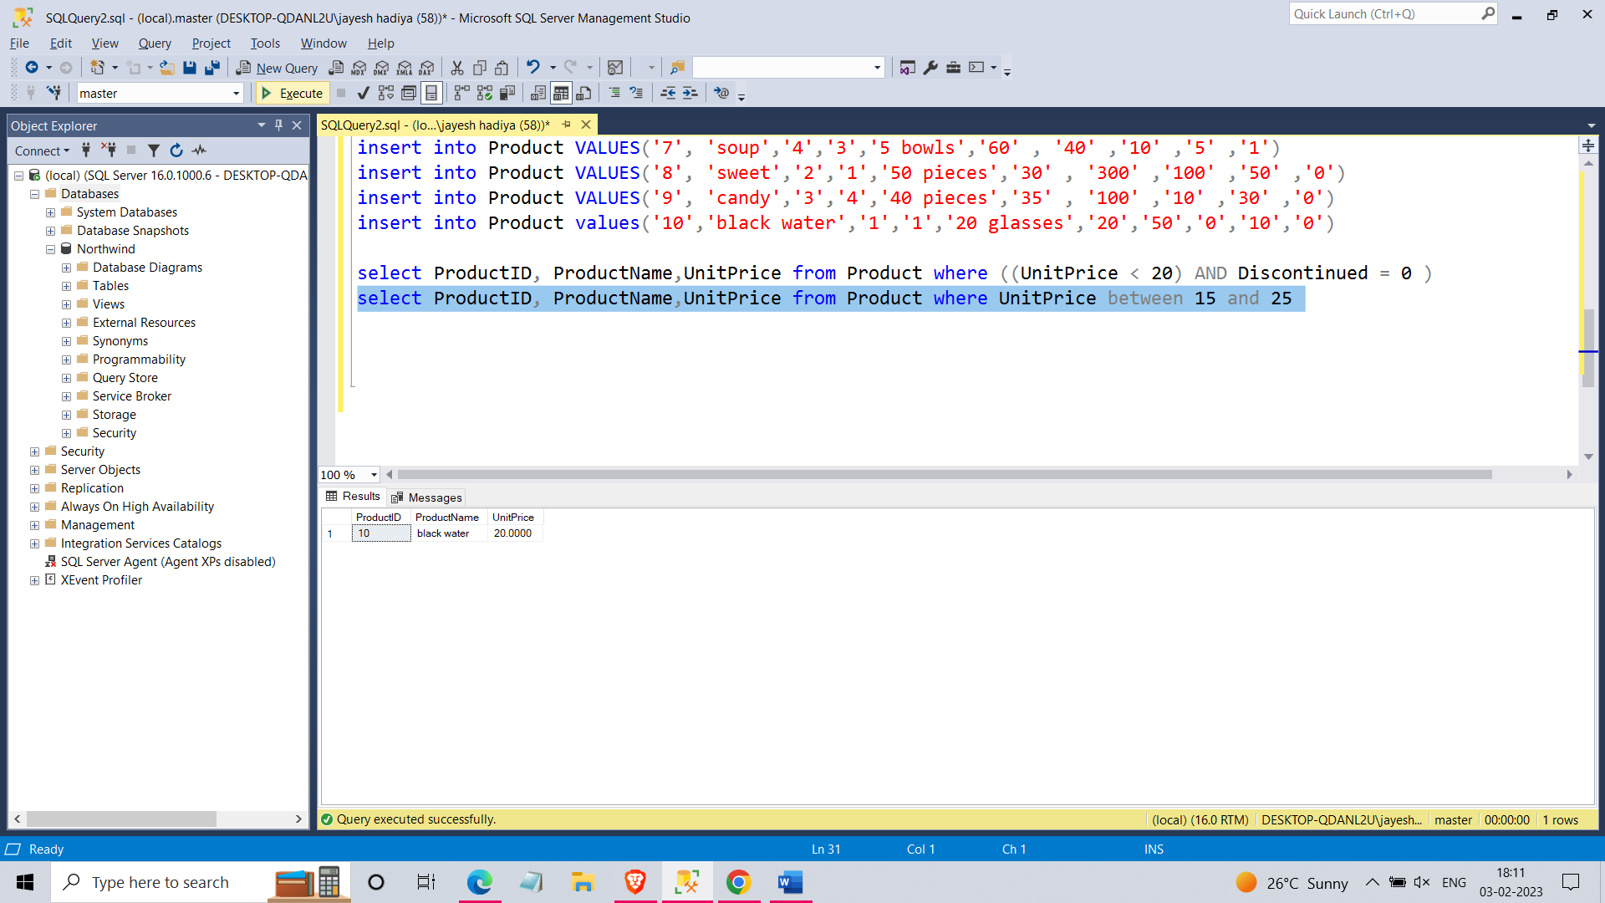

**3.** **Write a query to get Product list (name, unit price) of above average price.**

select distinct ProductName, UnitPrice from Product

where UnitPrice > (SELECT avg(UnitPrice) FROM Product)

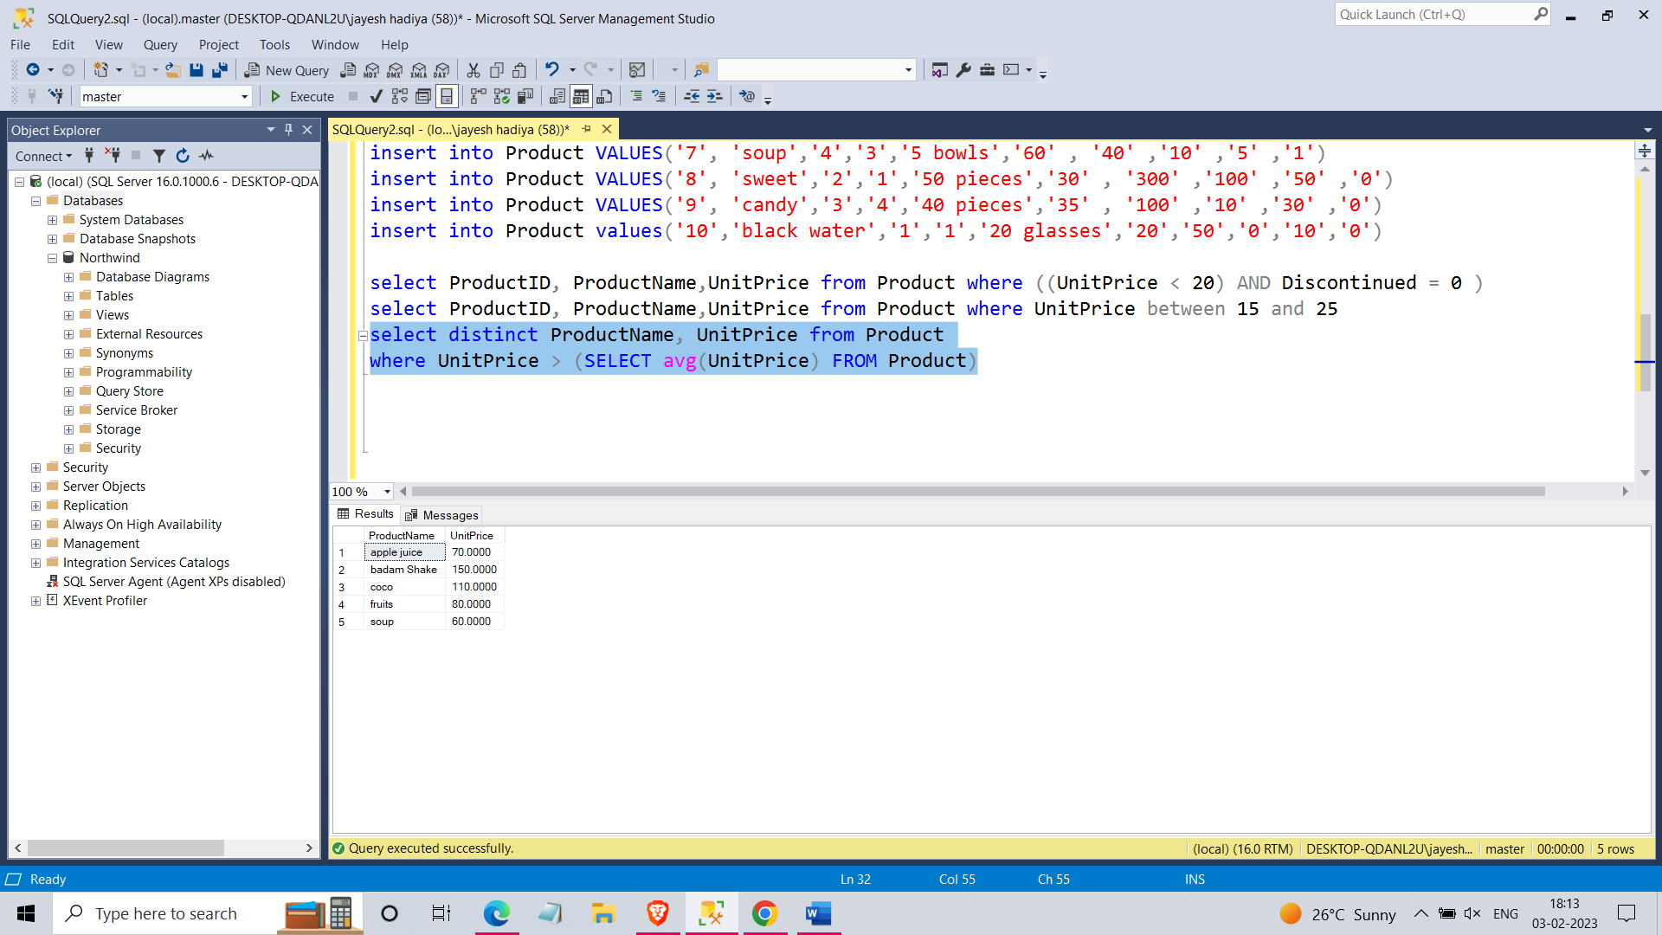

**4.** **Write a query to get Product list (name, unit price) of ten most expensive products**

select top 10 ProductName, UnitPrice from Product order by UnitPrice desc

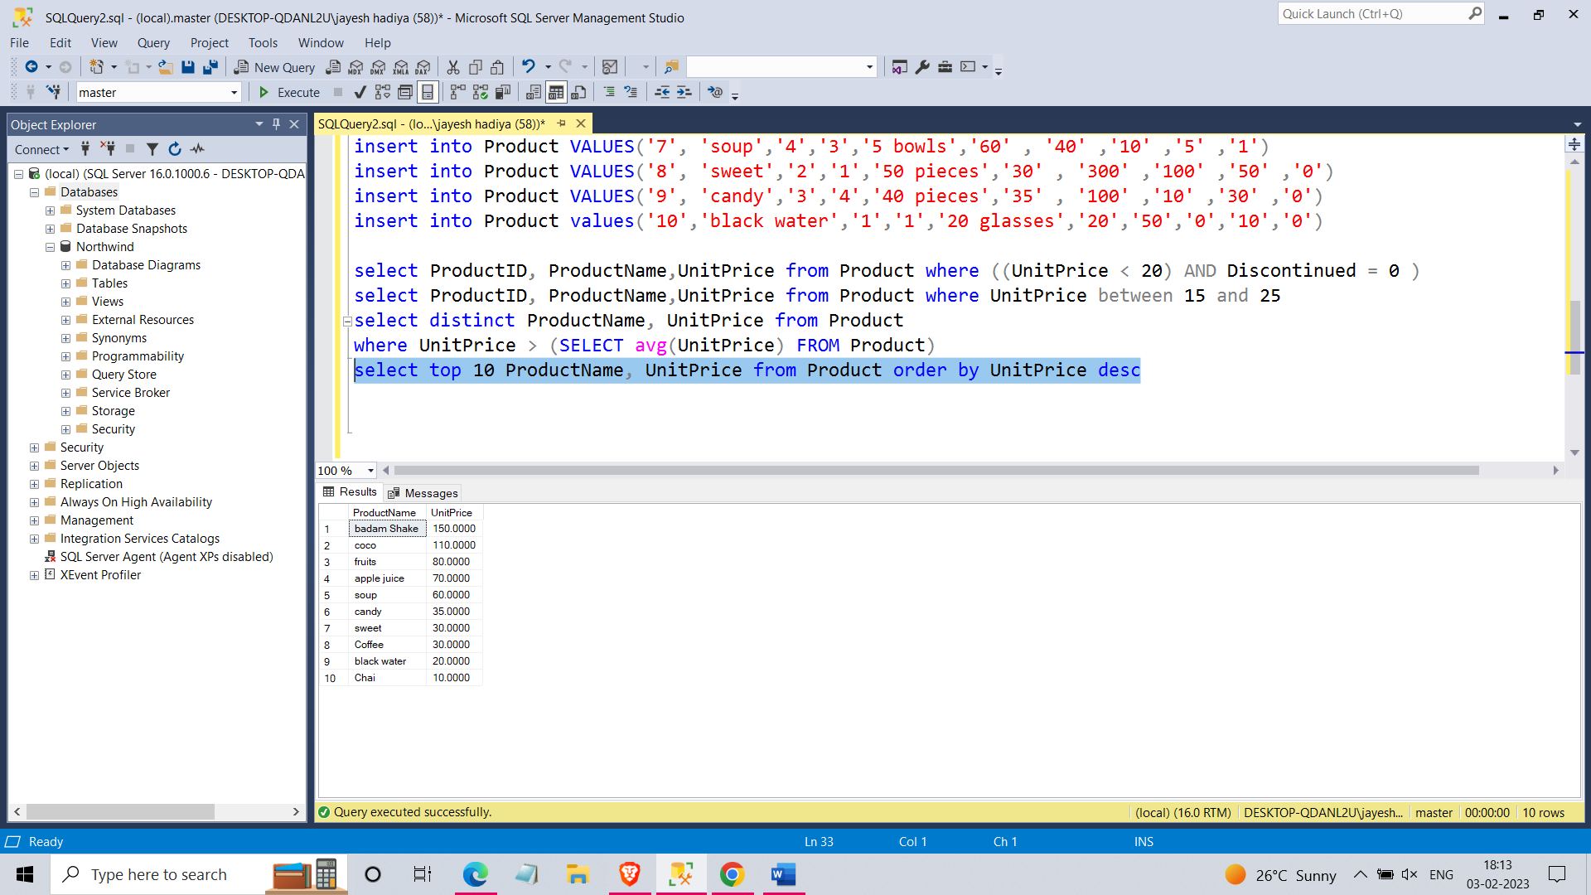

**5.** **Write a query to count current and discontinued products**

select count(productName) from Product group by Discontinued

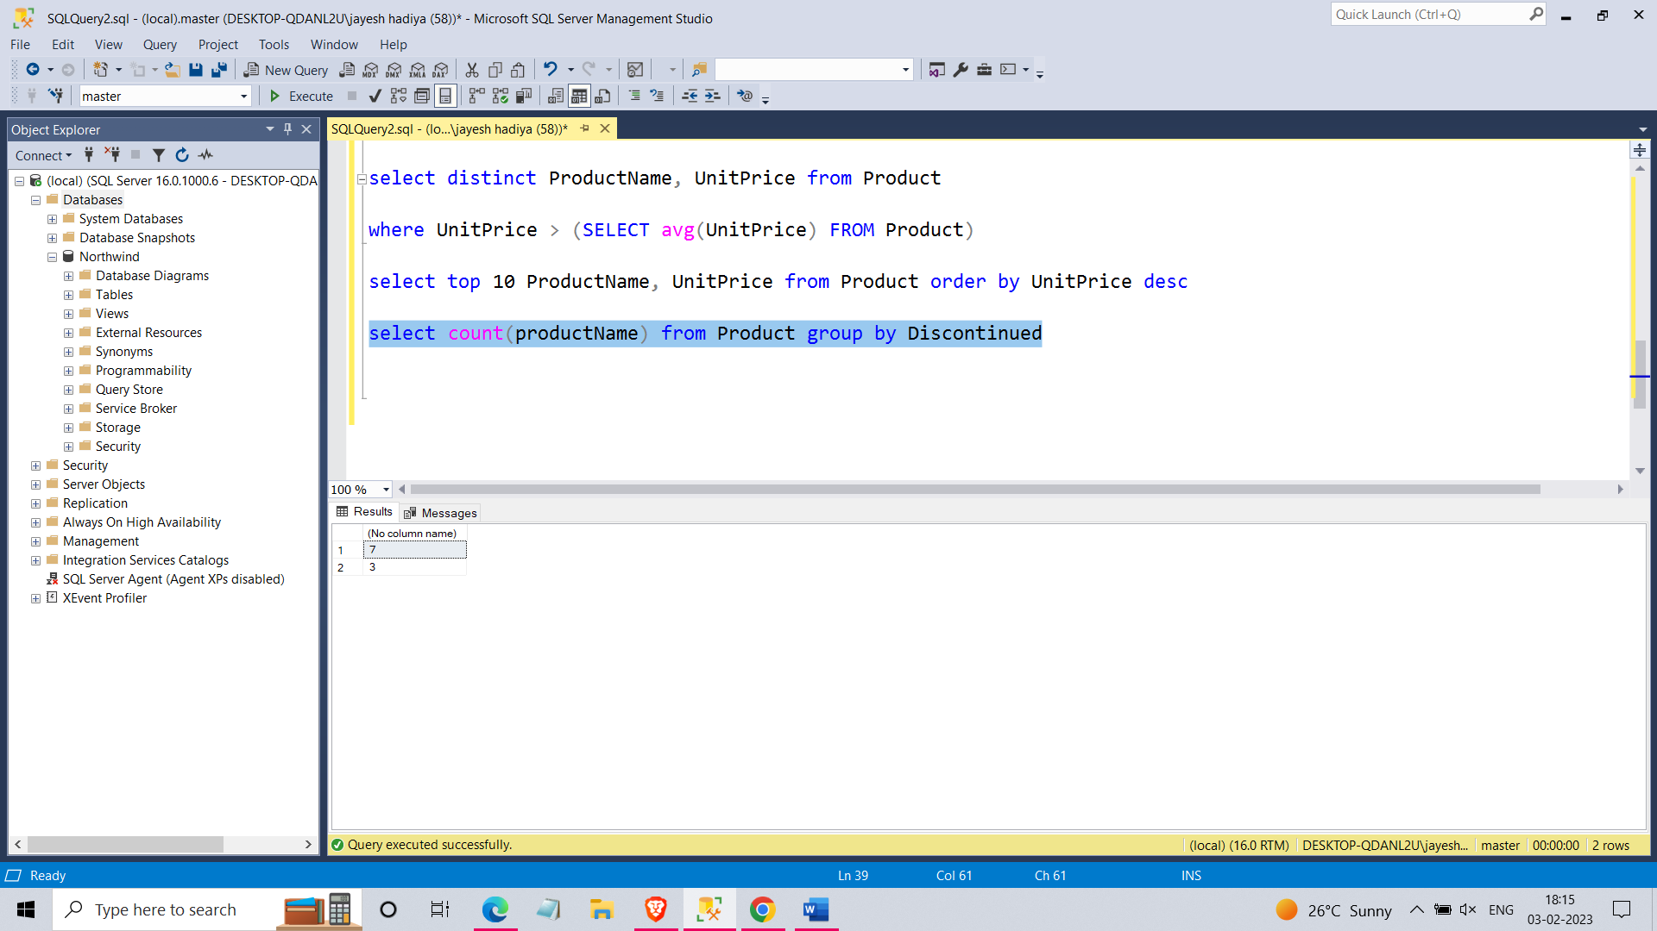

**6.** **Write a query to get Product list (name, units on order , units in stock) of stock is less than the quantity on order**

select ProductName,UnitsOnOrder,UnitsInStock from Product where UnitsInStock < UnitsOnOrder

